# **Arithmetic Operators and Expressions**

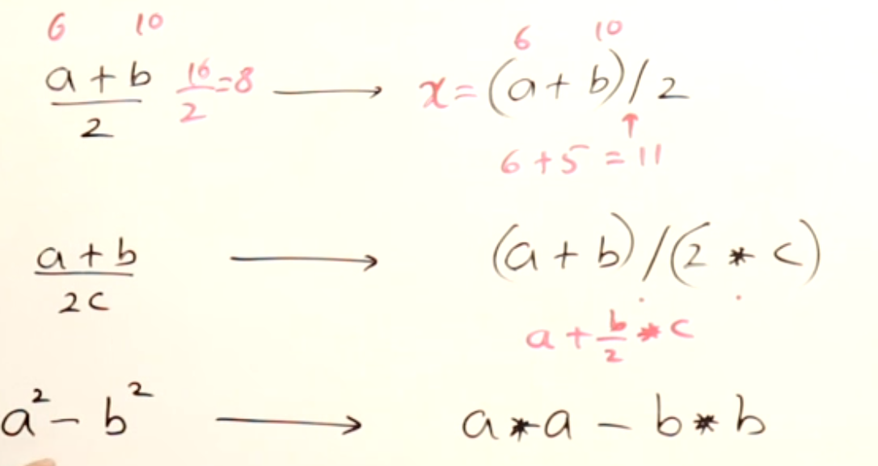

Paranthesis () is used to change the precedence of the operators.

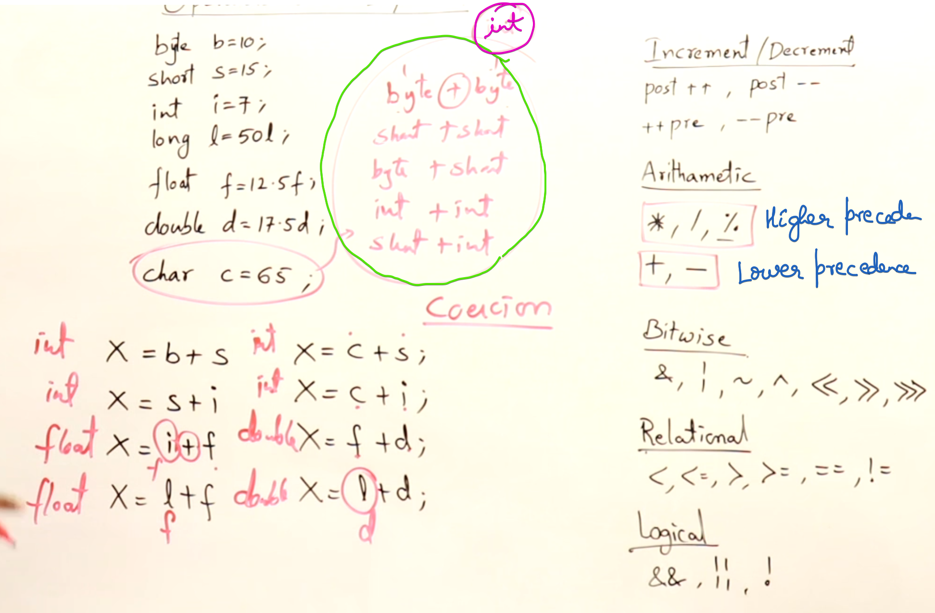

# **Increment and Decrement**

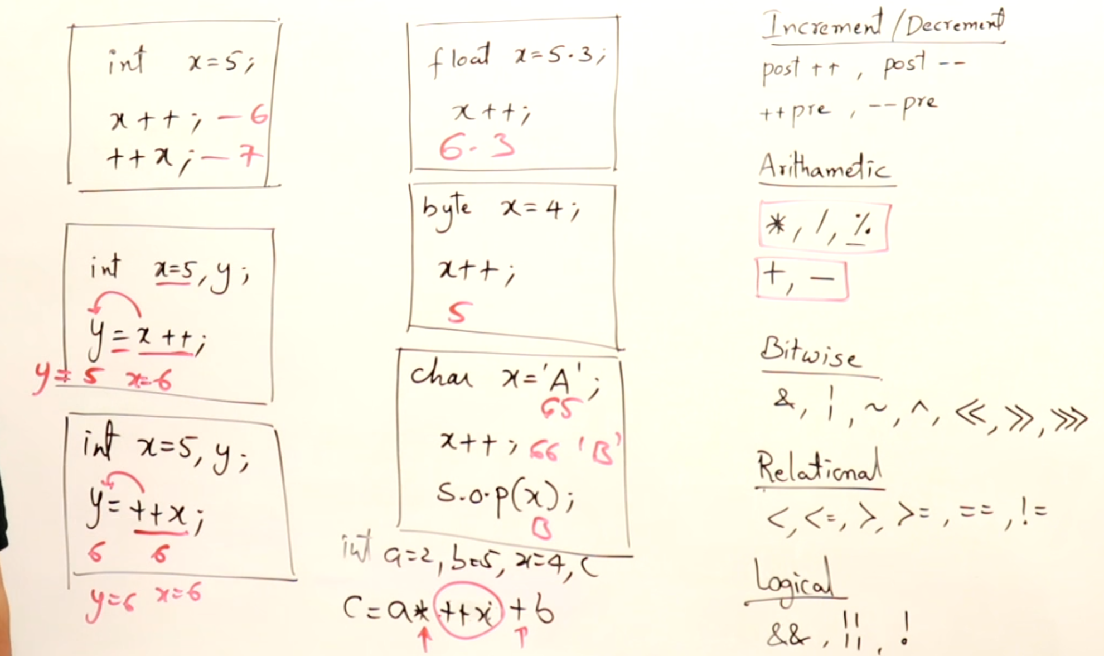

# **Bit-wise Operators**

Right shift

Left shift

No bits reserved for sign all the bits represents only magnitude.  
1 bit is reserved for sign it-self remaining (n-1) bits represents only magnitude.

Signed right shift

Unsigned right shift